**Exercise 1: Configuring a Basic Spring Application**

**pom.xml**

<project xmlns="http://maven.apache.org/POM/4.0.0"

xmlns:xsi="http://www.w3.org/2001/XMLSchema-instance"

xsi:schemaLocation="http://maven.apache.org/POM/4.0.0

http://maven.apache.org/xsd/maven-4.0.0.xsd">

<modelVersion>4.0.0</modelVersion>

<groupId>com.library</groupId>

<artifactId>LibraryManagement</artifactId>

<version>1.0-SNAPSHOT</version>

<dependencies>

<dependency>

<groupId>org.springframework</groupId>

<artifactId>spring-context</artifactId>

<version>5.3.30</version>

</dependency>

</dependencies>

<build>

<plugins>

<plugin>

<groupId>org.codehaus.mojo</groupId>

<artifactId>exec-maven-plugin</artifactId>

<version>3.1.0</version>

<configuration>

<mainClass>com.library.MainApp</mainClass>

</configuration>

</plugin>

</plugins>

</build>

</project>

**BookRepository.java**

package com.library;

public class BookRepository {

public void saveBook(String bookName) {

System.out.println("Book '" + bookName + "' saved to repository.");

}

}

**BookService.java**

package com.library;

public class BookService {

private BookRepository bookRepository;

public void setBookRepository(BookRepository bookRepository) {

this.bookRepository = bookRepository;

}

public void addBook(String bookName) {

System.out.println("Adding book: " + bookName);

bookRepository.saveBook(bookName);

}

}

**MainApp.java**

package com.library;

import org.springframework.context.ApplicationContext;

import org.springframework.context.support.ClassPathXmlApplicationContext;

public class MainApp {

public static void main(String[] args) {

ApplicationContext context = new ClassPathXmlApplicationContext("applicationContext.xml");

BookService bookService = context.getBean("bookService", BookService.class);

bookService.addBook("Spring in Action");

}

}

**applicationContext.xml**

<?xml version="1.0" encoding="UTF-8"?>

<beans xmlns="http://www.springframework.org/schema/beans"

xmlns:xsi="http://www.w3.org/2001/XMLSchema-instance"

xsi:schemaLocation="http://www.springframework.org/schema/beans

http://www.springframework.org/schema/beans/spring-beans.xsd">

<bean id="bookRepository" class="com.library.BookRepository"/>

<bean id="bookService" class="com.library.BookService">

<property name="bookRepository" ref="bookRepository"/>

</bean>

</beans>

**Output:**

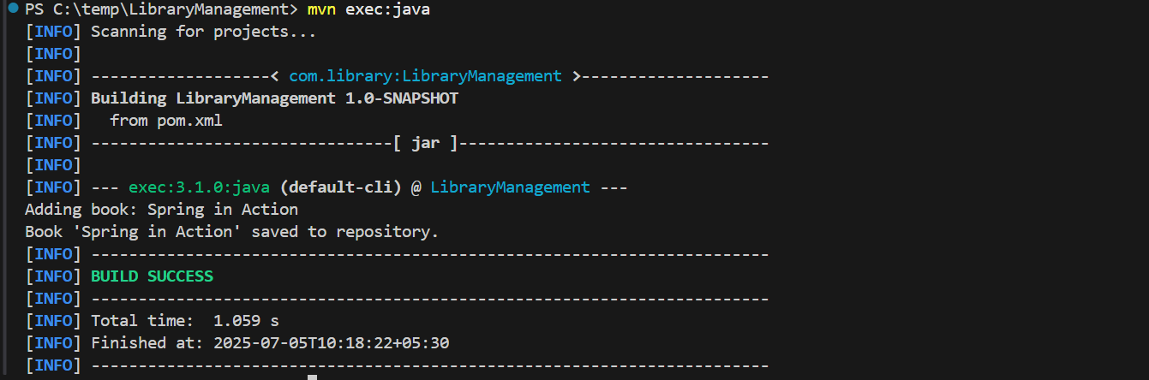

**Exercise 2: Implementing Dependency Injection**

**pom.xml**

<project xmlns="http://maven.apache.org/POM/4.0.0"

xmlns:xsi="http://www.w3.org/2001/XMLSchema-instance"

xsi:schemaLocation="http://maven.apache.org/POM/4.0.0

http://maven.apache.org/xsd/maven-4.0.0.xsd">

<modelVersion>4.0.0</modelVersion>

<groupId>com.library</groupId>

<artifactId>LibraryManagement</artifactId>

<version>1.0-SNAPSHOT</version>

<dependencies>

<dependency>

<groupId>org.springframework</groupId>

<artifactId>spring-context</artifactId>

<version>5.3.30</version>

</dependency>

</dependencies>

<build>

<plugins>

<plugin>

<groupId>org.codehaus.mojo</groupId>

<artifactId>exec-maven-plugin</artifactId>

<version>3.1.0</version>

<configuration>

<mainClass>com.library.MainApp</mainClass>

</configuration>

</plugin>

</plugins>

</build>

</project>

**BookRepository.java**

package com.library;

public class BookRepository {

public void saveBook(String bookName) {

System.out.println("Book '" + bookName + "' saved to repository.");

}

}

**BookService.java**

package com.library;

public class BookService {

private BookRepository bookRepository;

public void setBookRepository(BookRepository bookRepository) {

this.bookRepository = bookRepository;

}

public void addBook(String bookName) {

System.out.println("Adding book: " + bookName);

bookRepository.saveBook(bookName);

}

}

**MainApp.java**

package com.library;

import org.springframework.context.ApplicationContext;

import org.springframework.context.support.ClassPathXmlApplicationContext;

public class MainApp {

public static void main(String[] args) {

ApplicationContext context = new ClassPathXmlApplicationContext("applicationContext.xml");

BookService bookService = context.getBean("bookService", BookService.class);

bookService.addBook("Effective Java");

}

}

**applicationContext.xml**

<?xml version="1.0" encoding="UTF-8"?>

<beans xmlns="http://www.springframework.org/schema/beans"

xmlns:xsi="http://www.w3.org/2001/XMLSchema-instance"

xsi:schemaLocation="http://www.springframework.org/schema/beans

http://www.springframework.org/schema/beans/spring-beans.xsd">

<bean id="bookRepository" class="com.library.BookRepository" />

<bean id="bookService" class="com.library.BookService">

<property name="bookRepository" ref="bookRepository" />

</bean>

</beans>

**Output:**

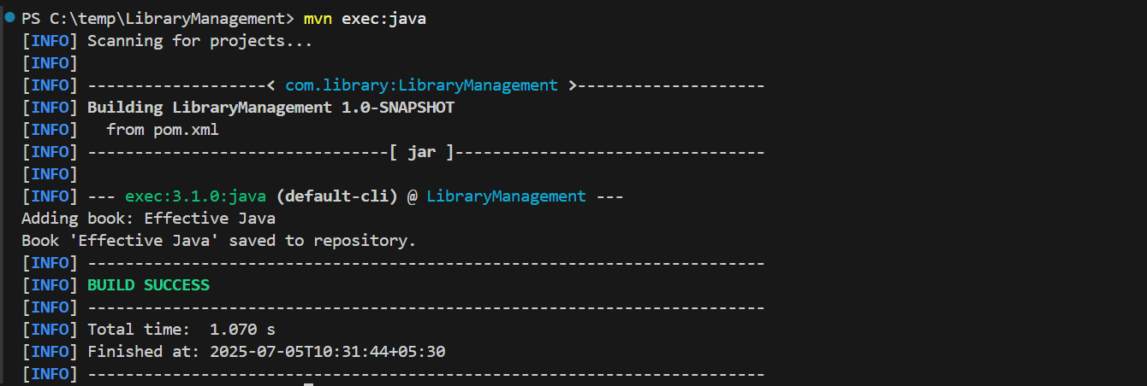

**Exercise 3: Implementing Logging with Spring AOP**

**pom.xml**

<project xmlns="http://maven.apache.org/POM/4.0.0"

xmlns:xsi="http://www.w3.org/2001/XMLSchema-instance"

xsi:schemaLocation="http://maven.apache.org/POM/4.0.0

http://maven.apache.org/xsd/maven-4.0.0.xsd">

<modelVersion>4.0.0</modelVersion>

<groupId>com.library</groupId>

<artifactId>LibraryManagement</artifactId>

<version>1.0-SNAPSHOT</version>

<packaging>jar</packaging>

<properties>

<maven.compiler.source>1.8</maven.compiler.source>

<maven.compiler.target>1.8</maven.compiler.target>

</properties>

<dependencies>

<dependency>

<groupId>org.springframework</groupId>

<artifactId>spring-core</artifactId>

<version>5.3.33</version>

</dependency>

<dependency>

<groupId>org.springframework</groupId>

<artifactId>spring-context</artifactId>

<version>5.3.33</version>

</dependency>

<dependency>

<groupId>org.springframework</groupId>

<artifactId>spring-aop</artifactId>

<version>5.3.33</version>

</dependency>

<dependency>

<groupId>org.aspectj</groupId>

<artifactId>aspectjweaver</artifactId>

<version>1.9.21</version>

</dependency>

</dependencies>

<build>

<resources>

<resource>

<directory>src/main/resources</directory>

</resource>

</resources>

<plugins>

<plugin>

<groupId>org.codehaus.mojo</groupId>

<artifactId>exec-maven-plugin</artifactId>

<version>3.1.0</version>

<configuration>

<mainClass>com.library.LibraryManagementApplication</mainClass>

</configuration>

</plugin>

</plugins>

</build>

</project>

**applicationContext.xml**

<?xml version="1.0" encoding="UTF-8"?>

<beans xmlns="http://www.springframework.org/schema/beans"

xmlns:context="http://www.springframework.org/schema/context"

xmlns:aop="http://www.springframework.org/schema/aop"

xmlns:xsi="http://www.w3.org/2001/XMLSchema-instance"

xsi:schemaLocation="

http://www.springframework.org/schema/beans

http://www.springframework.org/schema/beans/spring-beans.xsd

http://www.springframework.org/schema/context

http://www.springframework.org/schema/context/spring-context.xsd

http://www.springframework.org/schema/aop

http://www.springframework.org/schema/aop/spring-aop.xsd">

<context:component-scan base-package="com.library"/>

<aop:aspectj-autoproxy/>

<bean id="loggingAspect" class="com.library.LoggingAspect"/>

</beans>

**BookService.java**

package com.library;

import org.springframework.stereotype.Component;

@Component

public class BookService {

public void addBook(String bookName) {

System.out.println("Adding book: " + bookName);

try { Thread.sleep(100); } catch (InterruptedException ignored) {}

System.out.println("Book '" + bookName + "' saved to repository.");

}

}

**LoggingAspect.java**

package com.library;

import org.aspectj.lang.ProceedingJoinPoint;

import org.aspectj.lang.annotation.Around;

import org.aspectj.lang.annotation.Aspect;

@Aspect

public class LoggingAspect {

@Around("execution(* com.library.*.*(..))")

public Object logExecutionTime(ProceedingJoinPoint joinPoint) throws Throwable {

long startTime = System.currentTimeMillis();

Object result = joinPoint.proceed();

long endTime = System.currentTimeMillis();

System.out.println("[LOG] Method " + joinPoint.getSignature() + " executed in " + (endTime - startTime) + " ms");

return result;

}

}

**LibraryManagementApplication.java**

package com.library;

import org.springframework.context.ApplicationContext;

import org.springframework.context.support.ClassPathXmlApplicationContext;

public class LibraryManagementApplication {

public static void main(String[] args) {

ApplicationContext context = new ClassPathXmlApplicationContext("applicationContext.xml");

BookService bookService = (BookService) context.getBean("bookService");

bookService.addBook("Spring Microservices");

}

}

**Output:**

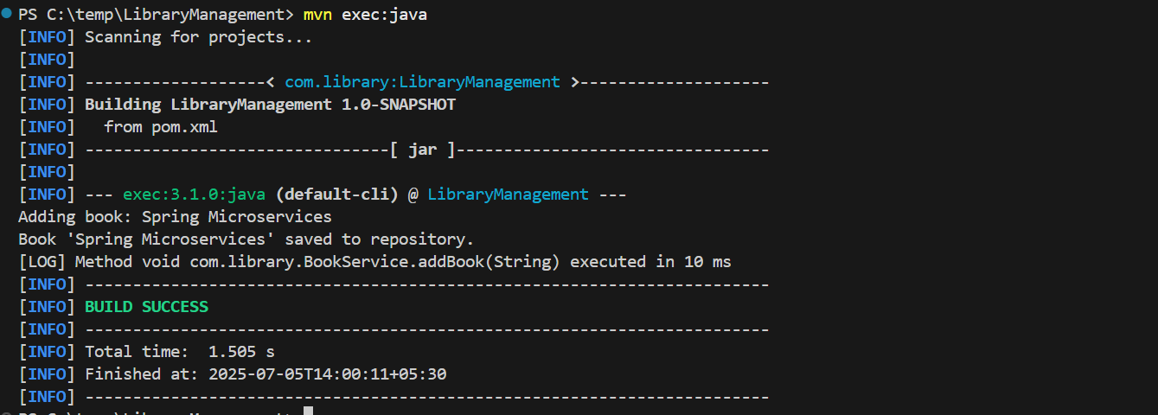

**Exercise 4: Creating and Configuring a Maven Project**

**pom.xml**

<project xmlns="http://maven.apache.org/POM/4.0.0"

xmlns:xsi="http://www.w3.org/2001/XMLSchema-instance"

xsi:schemaLocation="http://maven.apache.org/POM/4.0.0

http://maven.apache.org/xsd/maven-4.0.0.xsd">

<modelVersion>4.0.0</modelVersion>

<groupId>com.library</groupId>

<artifactId>LibraryManagement</artifactId>

<version>1.0-SNAPSHOT</version>

<packaging>jar</packaging>

<properties>

<maven.compiler.source>1.8</maven.compiler.source>

<maven.compiler.target>1.8</maven.compiler.target>

</properties>

<dependencies>

<dependency>

<groupId>org.springframework</groupId>

<artifactId>spring-core</artifactId>

<version>5.3.33</version>

</dependency>

<dependency>

<groupId>org.springframework</groupId>

<artifactId>spring-context</artifactId>

<version>5.3.33</version>

</dependency>

<dependency>

<groupId>org.springframework</groupId>

<artifactId>spring-aop</artifactId>

<version>5.3.33</version>

</dependency>

<dependency>

<groupId>org.springframework</groupId>

<artifactId>spring-webmvc</artifactId>

<version>5.3.33</version>

</dependency>

<dependency>

<groupId>org.aspectj</groupId>

<artifactId>aspectjweaver</artifactId>

<version>1.9.21</version>

</dependency>

</dependencies>

<build>

<resources>

<resource>

<directory>src/main/resources</directory>

</resource>

</resources>

<plugins>

<plugin>

<groupId>org.apache.maven.plugins</groupId>

<artifactId>maven-compiler-plugin</artifactId>

<version>3.10.1</version>

<configuration>

<source>1.8</source>

<target>1.8</target>

</configuration>

</plugin>

<plugin>

<groupId>org.codehaus.mojo</groupId>

<artifactId>exec-maven-plugin</artifactId>

<version>3.1.0</version>

<configuration>

<mainClass>com.library.LibraryManagementApplication</mainClass>

</configuration>

</plugin>

</plugins>

</build>

</project>

**applicationContext.xml**

<?xml version="1.0" encoding="UTF-8"?>

<beans xmlns="http://www.springframework.org/schema/beans"

xmlns:context="http://www.springframework.org/schema/context"

xmlns:xsi="http://www.w3.org/2001/XMLSchema-instance"

xsi:schemaLocation="

http://www.springframework.org/schema/beans

http://www.springframework.org/schema/beans/spring-beans.xsd

http://www.springframework.org/schema/context

http://www.springframework.org/schema/context/spring-context.xsd">

<context:component-scan base-package="com.library"/>

</beans>

**BookService.java**

package com.library;

import org.springframework.stereotype.Component;

@Component

public class BookService {

public void addBook(String bookName) {

System.out.println("📚 Adding book: " + bookName);

}

}

**LibraryManagementApplication.java**

package com.library;

import org.springframework.context.ApplicationContext;

import org.springframework.context.support.ClassPathXmlApplicationContext;

public class LibraryManagementApplication {

public static void main(String[] args) {

ApplicationContext context = new ClassPathXmlApplicationContext("applicationContext.xml");

BookService bookService = (BookService) context.getBean("bookService");

bookService.addBook("Spring Boot in Action");

}

}

**Output:**

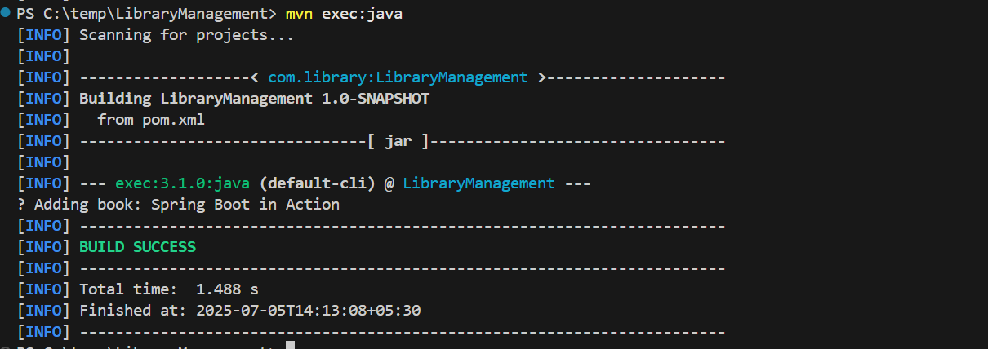

**Exercise 5: Configuring the Spring IoC Container**

**BookRepository.java**

package com.library;

public class BookRepository {

public void save(String bookName) {

System.out.println("Saving book: " + bookName);

}

}

**BookService.java**

package com.library;

public class BookService {

private BookRepository bookRepository;

public void setBookRepository(BookRepository bookRepository) {

this.bookRepository = bookRepository;

}

public void addBook(String bookName) {

System.out.println("Adding book: " + bookName);

bookRepository.save(bookName);

}

}

**applicationContext.xml**

<?xml version="1.0" encoding="UTF-8"?>

<beans xmlns="http://www.springframework.org/schema/beans"

xmlns:xsi="http://www.w3.org/2001/XMLSchema-instance"

xsi:schemaLocation="

http://www.springframework.org/schema/beans

http://www.springframework.org/schema/beans/spring-beans.xsd">

<bean id="bookRepository" class="com.library.BookRepository" />

<bean id="bookService" class="com.library.BookService">

<property name="bookRepository" ref="bookRepository"/>

</bean>

</beans>

**LibraryManagementApplication.java**

package com.library;

import org.springframework.context.ApplicationContext;

import org.springframework.context.support.ClassPathXmlApplicationContext;

public class LibraryManagementApplication {

public static void main(String[] args) {

ApplicationContext context = new ClassPathXmlApplicationContext("applicationContext.xml");

BookService bookService = (BookService) context.getBean("bookService");

bookService.addBook("Spring Framework Essentials");

}

}

**Output:**

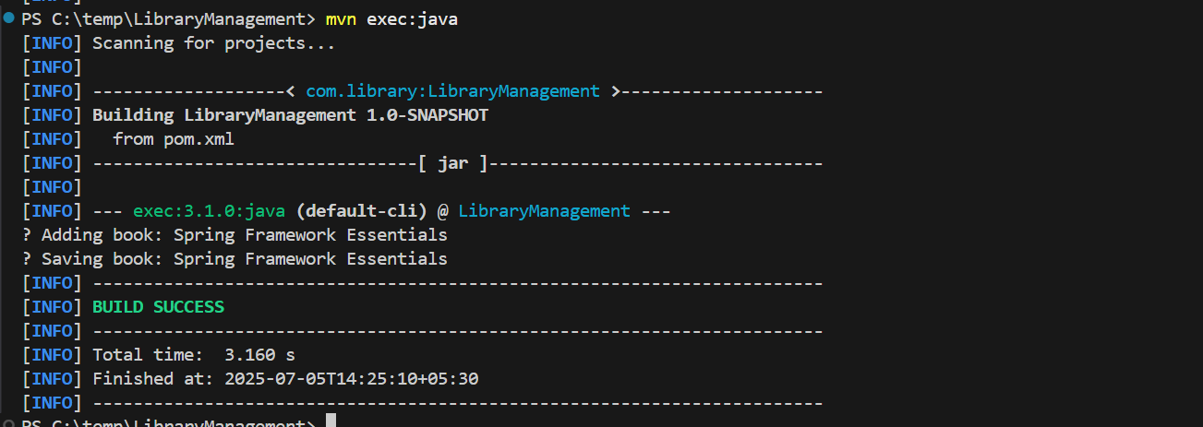

**Exercise 6: Configuring Beans with Annotations**

**applicationContext.xml**

<?xml version="1.0" encoding="UTF-8"?>

<beans xmlns="http://www.springframework.org/schema/beans"

xmlns:context="http://www.springframework.org/schema/context"

xmlns:xsi="http://www.w3.org/2001/XMLSchema-instance"

xsi:schemaLocation="

http://www.springframework.org/schema/beans

http://www.springframework.org/schema/beans/spring-beans.xsd

http://www.springframework.org/schema/context

http://www.springframework.org/schema/context/spring-context.xsd">

<context:component-scan base-package="com.library"/>

</beans>

**BookRepository.java**

package com.library;

import org.springframework.stereotype.Repository;

@Repository

public class BookRepository {

public void save(String bookName) {

System.out.println("Saving book: " + bookName);

}

}

**BookService.java**

package com.library;

import org.springframework.beans.factory.annotation.Autowired;

import org.springframework.stereotype.Service;

@Service

public class BookService {

private BookRepository bookRepository;

@Autowired

public BookService(BookRepository bookRepository) {

this.bookRepository = bookRepository;

}

public void addBook(String bookName) {

System.out.println(" Adding book: " + bookName);

bookRepository.save(bookName);

}

}

**LibraryManagementApplication.java**

package com.library;

import org.springframework.context.ApplicationContext;

import org.springframework.context.support.ClassPathXmlApplicationContext;

public class LibraryManagementApplication {

public static void main(String[] args) {

ApplicationContext context = new ClassPathXmlApplicationContext("applicationContext.xml");

BookService bookService = context.getBean(BookService.class);

bookService.addBook("Spring with Annotations");

}

}

**Output:**

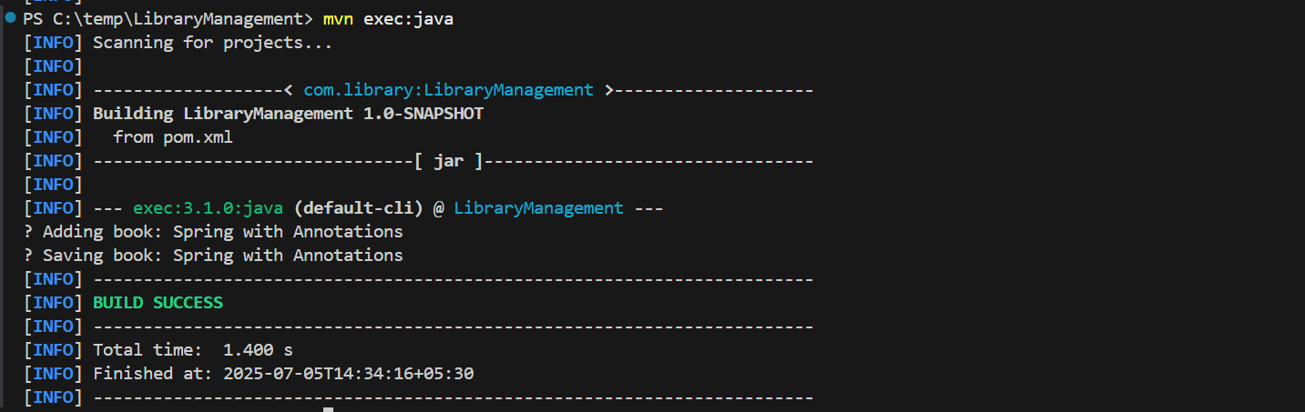

**Exercise 7: Implementing Constructor and Setter Injection**

**BookRepository.java**

package com.library;

public class BookRepository {

public void save(String bookName) {

System.out.println("Saving book: " + bookName);

}

}

**BookService.java**

package com.library;

public class BookService {

private BookRepository bookRepository;

private String libraryName;

public BookService(BookRepository bookRepository) {

this.bookRepository = bookRepository;

System.out.println("Constructor Injection: BookRepository injected");

}

public void setLibraryName(String libraryName) {

this.libraryName = libraryName;

System.out.println("Setter Injection: libraryName set to " + libraryName);

}

public void addBook(String bookName) {

System.out.println(" [" + libraryName + "] Adding book: " + bookName);

bookRepository.save(bookName);

}

}

**applicationContext.xml**

<?xml version="1.0" encoding="UTF-8"?>

<beans xmlns="http://www.springframework.org/schema/beans"

xmlns:xsi="http://www.w3.org/2001/XMLSchema-instance"

xsi:schemaLocation="

http://www.springframework.org/schema/beans

http://www.springframework.org/schema/beans/spring-beans.xsd">

<bean id="bookRepository" class="com.library.BookRepository" />

<bean id="bookService" class="com.library.BookService">

<constructor-arg ref="bookRepository"/>

<property name="libraryName" value="Central Library"/>

</bean>

</beans>

**LibraryManagementApplication.java**

package com.library;

import org.springframework.context.ApplicationContext;

import org.springframework.context.support.ClassPathXmlApplicationContext;

public class LibraryManagementApplication {

public static void main(String[] args) {

ApplicationContext context = new ClassPathXmlApplicationContext("applicationContext.xml");

BookService bookService = (BookService) context.getBean("bookService");

bookService.addBook("Spring DI Concepts");

}

}

**Output:**

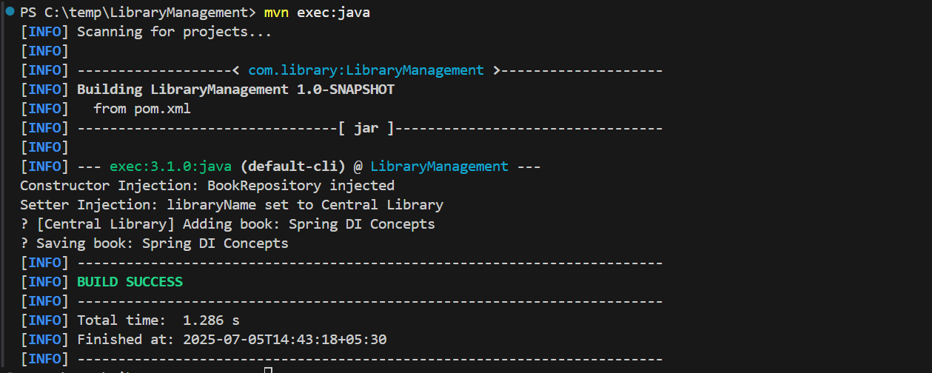

**Exercise 8: Implementing Basic AOP with Spring**

**BookRepository.java**

package com.library;

import org.springframework.stereotype.Repository;

@Repository

public class BookRepository {

public void save(String bookName) {

System.out.println("Saving book: " + bookName);

}

}

**BookService.java**

package com.library;

import org.springframework.beans.factory.annotation.Autowired;

import org.springframework.stereotype.Service;

@Service

public class BookService {

@Autowired

private BookRepository bookRepository;

public void addBook(String bookName) {

System.out.println(" Adding book: " + bookName);

bookRepository.save(bookName);

}

}

**LoggingAspect.java**

package com.library;

import org.aspectj.lang.JoinPoint;

import org.aspectj.lang.annotation.Aspect;

import org.aspectj.lang.annotation.Before;

import org.aspectj.lang.annotation.After;

import org.springframework.stereotype.Component;

@Aspect

@Component

public class LoggingAspect {

@Before("execution(* com.library.BookService.*(..))")

public void logBefore(JoinPoint joinPoint) {

System.out.println(" [Before] Method called: " + joinPoint.getSignature().getName());

}

@After("execution(* com.library.BookService.*(..))")

public void logAfter(JoinPoint joinPoint) {

System.out.println("[After] Method executed: " + joinPoint.getSignature().getName());

} }

**LibraryManagementApplication.java**

package com.library;

import org.springframework.context.ApplicationContext;

import org.springframework.context.support.ClassPathXmlApplicationContext;

public class LibraryManagementApplication {

public static void main(String[] args) {

ApplicationContext context = new ClassPathXmlApplicationContext("applicationContext.xml");

BookService bookService = context.getBean(BookService.class);

bookService.addBook("Spring AOP Without Aspect Folder");

}

}

**applicationContext.xml**

<?xml version="1.0" encoding="UTF-8"?>

<beans xmlns="http://www.springframework.org/schema/beans"

xmlns:context="http://www.springframework.org/schema/context"

xmlns:aop="http://www.springframework.org/schema/aop"

xmlns:xsi="http://www.w3.org/2001/XMLSchema-instance"

xsi:schemaLocation="

http://www.springframework.org/schema/beans

http://www.springframework.org/schema/beans/spring-beans.xsd

http://www.springframework.org/schema/context

http://www.springframework.org/schema/context/spring-context.xsd

http://www.springframework.org/schema/aop

http://www.springframework.org/schema/aop/spring-aop.xsd">

<context:component-scan base-package="com.library"/>

<aop:aspectj-autoproxy />

</beans>

**pom.xml**

<project xmlns="http://maven.apache.org/POM/4.0.0"

xmlns:xsi="http://www.w3.org/2001/XMLSchema-instance"

xsi:schemaLocation="http://maven.apache.org/POM/4.0.0

http://maven.apache.org/xsd/maven-4.0.0.xsd">

<modelVersion>4.0.0</modelVersion>

<groupId>com.library</groupId>

<artifactId>LibraryManagement</artifactId>

<version>1.0-SNAPSHOT</version>

<dependencies>

<dependency>

<groupId>org.springframework</groupId>

<artifactId>spring-context</artifactId>

<version>5.3.33</version>

</dependency>

<dependency>

<groupId>org.springframework</groupId>

<artifactId>spring-aop</artifactId>

<version>5.3.33</version>

</dependency>

<dependency>

<groupId>org.aspectj</groupId>

<artifactId>aspectjweaver</artifactId>

<version>1.9.21</version>

</dependency>

</dependencies>

<build>

<resources>

<resource>

<directory>src/main/resources</directory>

</resource>

</resources>

<plugins>

<plugin>

<groupId>org.codehaus.mojo</groupId>

<artifactId>exec-maven-plugin</artifactId>

<version>3.1.0</version>

<configuration>

<mainClass>com.library.LibraryManagementApplication</mainClass>

</configuration>

</plugin>

</plugins>

</build>

</project>

**Output:**

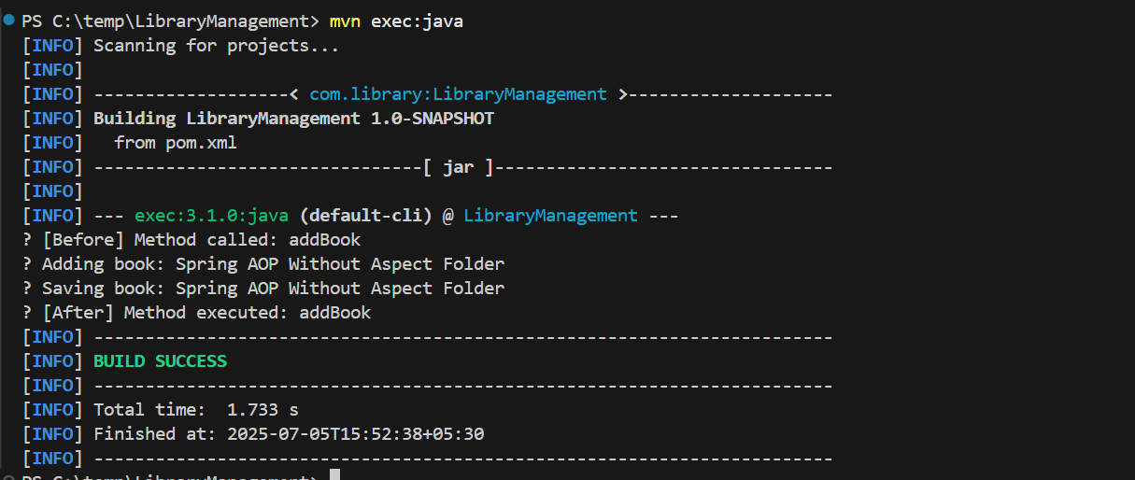

**Exercise 9: Creating a Spring Boot Application**

**pom.xml**

<project xmlns="http://maven.apache.org/POM/4.0.0"

xmlns:xsi="http://www.w3.org/2001/XMLSchema-instance"

xsi:schemaLocation="http://maven.apache.org/POM/4.0.0

http://maven.apache.org/xsd/maven-4.0.0.xsd">

<modelVersion>4.0.0</modelVersion>

<groupId>com.library</groupId>

<artifactId>LibraryManagement</artifactId>

<version>1.0.0</version>

<packaging>jar</packaging>

<name>LibraryManagement</name>

<description>Spring Boot Library Management System</description>

<parent>

<groupId>org.springframework.boot</groupId>

<artifactId>spring-boot-starter-parent</artifactId>

<version>3.2.4</version>

</parent>

<dependencies>

<dependency>

<groupId>org.springframework.boot</groupId>

<artifactId>spring-boot-starter-web</artifactId>

</dependency>

<dependency>

<groupId>org.springframework.boot</groupId>

<artifactId>spring-boot-starter-data-jpa</artifactId>

</dependency>

<dependency>

<groupId>com.h2database</groupId>

<artifactId>h2</artifactId>

<scope>runtime</scope>

</dependency>

</dependencies>

<properties>

<java.version>17</java.version>

</properties>

<build>

<plugins>

<plugin>

<groupId>org.apache.maven.plugins</groupId>

<artifactId>maven-compiler-plugin</artifactId>

<version>3.10.1</version>

<configuration>

<source>${java.version}</source>

<target>${java.version}</target>

</configuration>

</plugin>

</plugins>

</build>

</project>

**LibraryManagementApplication.java**

package com.library;

import org.springframework.boot.SpringApplication;

import org.springframework.boot.autoconfigure.SpringBootApplication;

@SpringBootApplication

public class LibraryManagementApplication {

public static void main(String[] args) {

SpringApplication.run(LibraryManagementApplication.class, args);

}

}

**Book.java**

package com.library.entity;

import jakarta.persistence.Entity;

import jakarta.persistence.GeneratedValue;

import jakarta.persistence.GenerationType;

import jakarta.persistence.Id;

@Entity

public class Book {

@Id

@GeneratedValue(strategy = GenerationType.IDENTITY)

private Long id;

private String title;

private String author;

public Book() {}

public Book(String title, String author) {

this.title = title;

this.author = author;

}

public Long getId() {

return id;

}

public void setId(Long id) { this.id = id; }

public String getTitle() {

return title;

}

public void setTitle(String title) { this.title = title; }

public String getAuthor() {

return author;

}

public void setAuthor(String author) { this.author = author; }

}

**BookRepository.java**

package com.library.repository;

import com.library.entity.Book;

import org.springframework.data.jpa.repository.JpaRepository;

public interface BookRepository extends JpaRepository<Book, Long> {

}

**BookController.java**

package com.library.controller;

import com.library.entity.Book;

import com.library.repository.BookRepository;

import org.springframework.beans.factory.annotation.Autowired;

import org.springframework.web.bind.annotation.*;

import java.util.List;

import java.util.Optional;

@RestController

@RequestMapping("/books")

public class BookController {

@Autowired

private BookRepository bookRepository;

@PostMapping

public Book addBook(@RequestBody Book book) {

return bookRepository.save(book);

}

@GetMapping

public List<Book> getAllBooks() {

return bookRepository.findAll();

}

@GetMapping("/{id}")

public Optional<Book> getBook(@PathVariable Long id) {

return bookRepository.findById(id);

}

@PutMapping("/{id}")

public Book updateBook(@PathVariable Long id, @RequestBody Book book) {

book.setId(id);

return bookRepository.save(book);

}

@DeleteMapping("/{id}")

public void deleteBook(@PathVariable Long id) {

bookRepository.deleteById(id);

}

}

**application.properties**

# H2 Database Configuration

spring.datasource.url=jdbc:h2:mem:librarydb

spring.datasource.driverClassName=org.h2.Driver

spring.datasource.username=sa

spring.datasource.password=

# JPA & Hibernate

spring.jpa.database-platform=org.hibernate.dialect.H2Dialect

spring.jpa.hibernate.ddl-auto=update

# H2 Console

spring.h2.console.enabled=true

spring.h2.console.path=/h2-console

**output:**

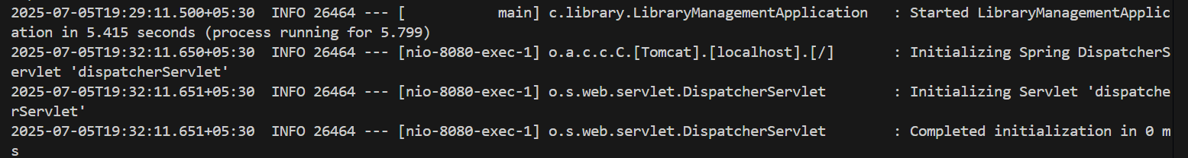

**Base URL**

[**http://localhost:8080/books**](http://localhost:8080/books)

**1.POST**

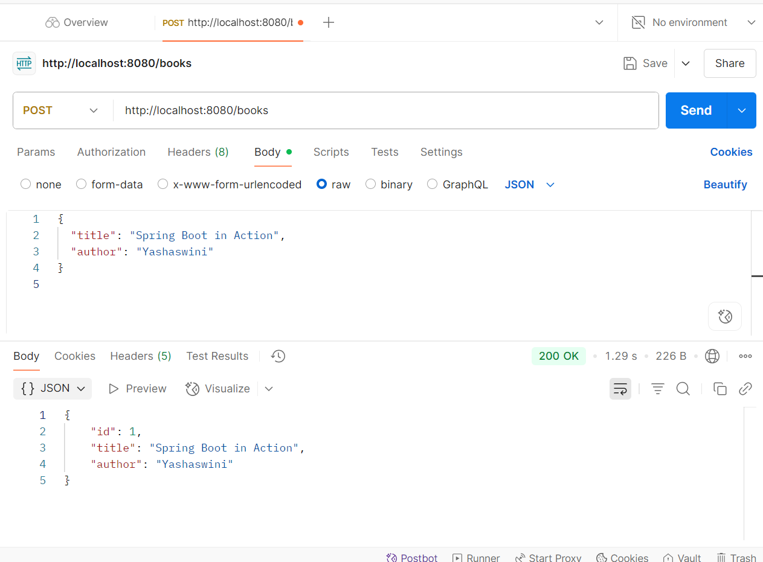

**2.GET**

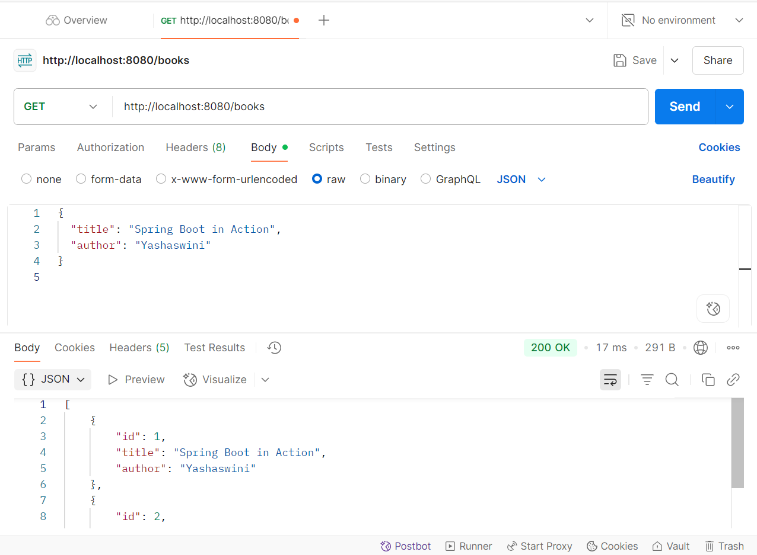

**3.PUT**

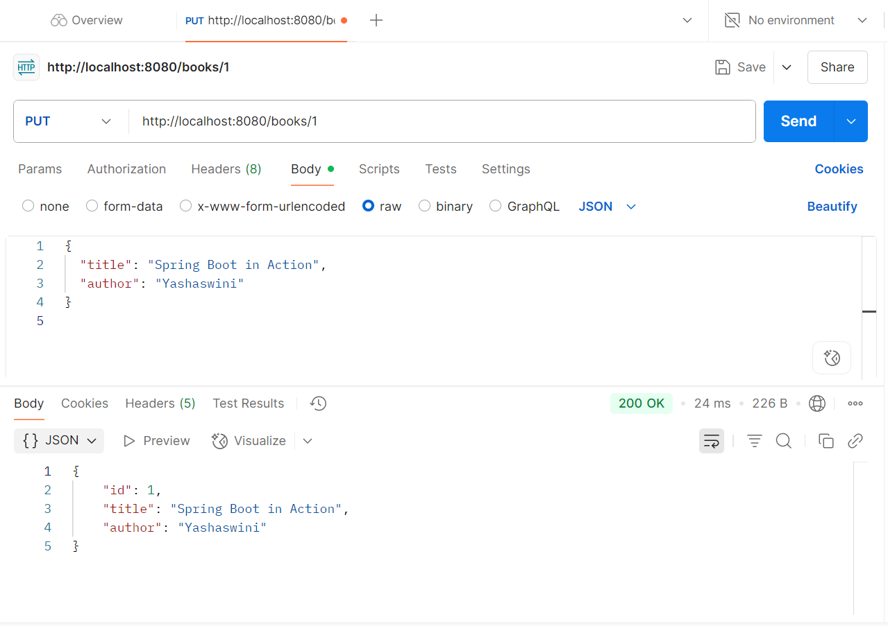

**4.DELETE**

